Task 11. Read this article, analyze it and be ready to discuss it on the 28th of April at 1:10 p.m.

Travel by TV: around the UK in 10 great shows
United Kingdom holidays
We can’t go out (much) but can still enjoy a journey around the country in the company of series featuring beautiful locations
Robert Hull
@Rob_Hull
Tue 21 Apr 2020 06.30 BSTLast modified on Tue 21 Apr 2020 07.08 BST

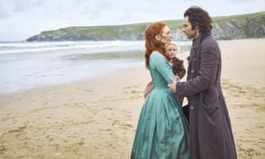
Have you seen where I put my scythe down? Aidan Turner and Eleanor Tomlinson on a Cornish beach, in Poldark. Photograph: Landmark Media/Alamy

Poldark, Cornwall
Yes, on occasion, the Cornish scenery even outshines the shirtless Ross Poldark scything away in the fields in the BBC’s historical drama. My mum speaks highly of the mid-1970s original, and though she can remember almost nothing about it, it’s probably fair to say the Cornish locations wouldn’t have dazzled back then the way they do in the high-def 2015 remake. Among them are Holywell Bay, Porthcurno beach, Kynance Cove and Porthgwarra. The exterior of Poldark’s perennially perilous Wheal Leisure mine is Botallack Mine on the Penwith peninsula, while giddyup and (pretend) gallop along as Ross and sourpuss-faced nemeses cross paths at the clifftops of Park Head near Porthcothan with their views to sea stacks at Bedruthan Steps.
• See also: Doc Martin, and Delicious

Liar, Kent and Essex

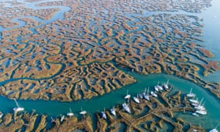

FacebookTwitterPinterest
No fibbing … Tollesbury Wick Marshes play a prominent role in Liar. Photograph: Rex/Shutterstock
There’s as much improbability in the plot as there is biodiversity in the Tollesbury Wick Marshes that provide this wriggly crime drama with its title sequence and visual motif. Audiences don’t seem to mind suspending disbelief, though (or coping with frequent utterings of “Nobody would blame you if you had …”), considering the online chatter, but they are also drawn by the show’s coastal locations. The town of Deal, in Kent, and its pier, takes the lion’s share of screen time but also look out for Margate, Kingsdown and Walmer. Kent’s thunder is stolen a little, however, as those gorgeous coastal freshwater marshes – as well as Tollesbury Marina – are in Essex.
• See also: Back to Life

Vera, Northumberland/the north-east

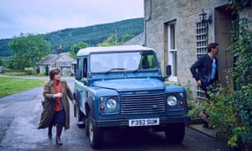

FacebookTwitterPinterest
Brenda Blethyn (left) and Kenny Doughty in Vera. Photograph: ITV/REX/Shutterstock
Roam around Northumberland in the company of the raincoat-wearing riddle-solver played by Brenda Blethyn. There’s no need to remain as dry-humoured/grumpy as her, though, because, a) you’re not doing the legwork or paperwork and, b) you get to see swathes of captivating north-east scenery. The tourism boost the show’s 10 series have given the region has been described by local press as the Vera Effect. So, jump onboard the (virtual) tour bus for trips from Clayton Street, Grainger Market and Jesmond in Newcastle to Whitley Bay, and north along the coast to Blyth, Amble, Alnmouth, Craster, Seahouses and Rumbling Kern. The show also takes you over to the evocative Farne Islands.
• See also: Our Friends in the North

Sex Education, Forest of Dean, Wye valley, Monmouthshire



FacebookTwitterPinterest
Ncuti Gatwa (left) as Eric and Asa Butterfield as Otis in the Netflix show Sex Education. Photograph: Sam Taylor/Netflix/Kobal/REX/Shutterstock
This Netflix Original series takes the countryside of the English/Welsh border and turns it into a drama meant to look like it is set in an American high-school. Amid meetings by lockers, the varsity jackets and “crazy” frat-like house parties, the time period and location are uncertain, but a New England-esque feel comes from locations including bridges at Redbrook, and Brockweir and Tintern’s Wireworks Bridge, plus sweeping shots over the River Wye. Tintern village features prominently, as do Bigsweir House on the Wye and Browns Village Stores in Llandogo. The awesome-looking red-and-white house that’s home to Otis (Asa Butterfield) and his mother, Jean (Gillian Anderson), is known as The Chalet – and it overlooks Symonds Yat. Monmouth high street, the lido at Lydney and Dean Forest Railway highlight how embedded the show is in filming in the region.
• See also: Hinterland, Gavin and Stacey

Broadchurch, Dorset

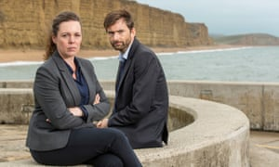

FacebookTwitterPinterest
National treasures … in a historic location. Olivia Colman (left) and David Tennant in a publicity shot for Broadchurch, in Dorset. Photograph: Colin Hutton/ITV
Roads never seem the quickest or most popular way of reaching anyone’s house, or caravan, in (fictional) Broadchurch – not when an evocative clifftop stroll or windswept beach walk can be taken instead. Across three series, Chris Chibnall’s contemporary crime drama places Jodie Whittaker, David Tennant and Olivia Colman in eye-catching Jurassic Coast locations, including Dorset’s West Bay, notably its Harbour Cliff and beach, West Cliff and East Pier. Bridport and Weymouth also get moments in the spotlight, while TV’s ability to pass off one location off as another means north Somerset’s Weston-super-Mare and Portishead feature.
• See also: If you can find it, Nick Berry’s Harbour Lights; while films include Far from the Madding Crowd (1967) and On Chesil Beach (2017)

Shetland, Scotland

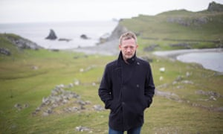

FacebookTwitterPinterest
DI Jimmy Perez (Douglas Henshall) in the crime drama Shetland. Photograph: Mark Mainz/BBC/ITV Studios
Confirming one of the first rules of crime drama – that bad things happen in bleak-but-beautiful locations – is this Tartan noir by crime writer Ann Cleeves. The show’s five series have made the Shetland Islands popular with tourists, though that has led to concerns about overtourism. So, perhaps travelling by TV will remain the best way to see them (even after Covid-19). The majority of exteriors are filmed on Shetland “Mainland”, including Lerwick, Sumburgh Head and Brae, though the islands of Bressay, Whalsay and Fair Isle feature, too.
• See also Case Histories (Edinburgh), The Nest (Glasgow)

Derry Girls, Northern Ireland

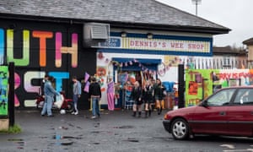

FacebookTwitterPinterest
The Derry Girls at Dennis’s Wee Shop. Photograph: Peter Marley/Channel 4
Derry Girls may be set in the mid-1990s but in Northern Ireland pebbledash is timeless. Join Erin and her mates (including token male James) as they wander Derry’s streets at a pace known only to teenagers. The show doesn’t often desert its hometown on the River Foyle (and when it does, it only goes as far as Belfast), featuring locations around the walled city, including the Foyle valley museum, Bogside Stores on Westland Street, as well as on Longtower and Limewood Streets: the latter is the steep street the gang walks down to school. The city has its own Derry Girls mural now – on the side of Badger’s Bar, on Orchard Street.
• See also: The Fall (Belfast)

The Trip, series 1, Lancashire, Cumbria, North Yorkshire

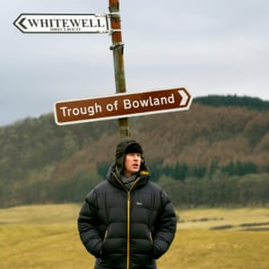

FacebookTwitterPinterest
Steve Coogan traversing ‘the north’ in The Trip, series 1. Photograph: TCD/Alamy
Let’s head back to 2010 for an original trip … listen carefully and you can hear Steve Coogan and Rob Brydon doing impressions at each other (yes, mainly the same ones they’re still doing 10 years later in series 4: clap hands twice, pout and shout “Oi, Keef!”). The first outing of The Trip took the duo on a food-and-feelings odyssey from Lancashire’s Ribble Valley to Hetton in the Yorkshire Dales, by way of the Lakes. Settle back and let Rob or Steve do the driving, while you marvel at rugged landscapes. Perhaps you could attempt a cook-along, or maybe perfect your Ronnie Corbett: adjust glasses, adopt faint Scottish accent: “Heh, heh, heh, as the producer said to me …”
• See also: The English Game (Saltaire, Bradford, Keighley & Worth Valley Railway)

Detectorists, Suffolk

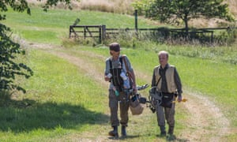

FacebookTwitterPinterest
Mackenzie Crook (left) and Toby Jones in a scene from Detectorists. Photograph: Jonathan Barclay/BBC/Channel X North/Treasure Trove/Lola Entertainment
Though set in Essex, this gentle, pastoral comedy starring Mackenzie Crook and Toby Jones is shot in Suffolk. It’s filmed predominantly in the market town of Framlingham, where Andy (Crook) and Lance’s (Jones) local, the Two Brewers, is actually the town’s Castle Inn, and the scout hut for their metal detecting club is St Michael’s Rooms – adjacent to Framlingham’s impressive Norman castle. Much of the show’s beauty, though, comes from their strolls through the countryside, including near Parham village and around Orford and Orford Ness national nature reserve.
• See also: Grantchester (Cambridgeshire), Alan Partridge (north Norfolk, naturally)

Deep Water, Lake District

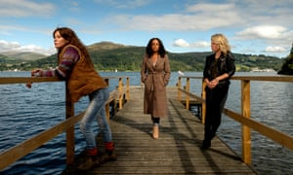

FacebookTwitterPinterest
Anna Friel (left) as Lisa, Rosalind Eleazar as Kate and Sinead Keenan (right) as Roz, in Deep Water. Photograph: ITV/REX/Shutterstock
Beanie hats and quality outerwear, intrigue, family drama and regular coffeeshop chats by the waterside, ITV’s Deep Water has been dubbed “Britain’s answer to Big Little Lies”. In fact, we, the Guardian, did the dubbing. Adapted from the Windermere series of novels by Paula Daly, there is plenty of scenery to feast on while following the lives of “three complex and vibrant women, each struggling to keep their heads above very deep water”. Thanks press release. Though it was shot mainly around Windermere (key characters Kate and Guy have a gorgeous home that overlooks it), there’s also screen time for Coniston Water – location of aforementioned coffeeshop, the Bluebird Café – and the pretty village of Hawkshead.
• See also: The Lakes, The A Word
Alternative viewing
Peaky Blinders (Birmingham), This is England 86 (Sheffield), This Country (Cotswolds), Cold Feet (Manchester), Save Me & Save Me Too (London), Luther (London)

