Task 7. Read the following article and be ready to discuss it in Skype on the 14th of April at 13:10. What’s more, search for some background information to learn more about the cult series.

Twin Peaks at 30: some damn fine outfits but what do they mean?
Fashion
It’s three decades since David Lynch’s groundbreaking TV show hit our screens, and the character’s clothes have aged as well as the drama
Lauren Cochrane
Wed 8 Apr 2020

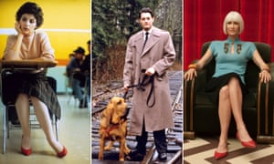
Looks that last … Audrey Horne, Special Agent Dale Cooper and Diane Evans. Composite: Alamy Stock Photo; ABC/Walt Disney Television via Getty Images; Suzanne Tenner
Twin Peaks – the series that brought us damn fine coffee, the Log Lady and, for some, a sudden distrust of owls – celebrates its 30th anniversary this week. Alongside a gripping plot centred on murdered schoolgirl Laura Palmer and Lynchian weirdness such as the red room, the series will always be remembered for its style. Catherine Spooner, professor of literature and culture at Lancaster University, and co-editor of Twin Peaks: New Approaches to Materiality, Theory and Genre on Television, says: “Virtually every character wears a kind of uniform conveying their role in the community.” Here are six characters who use fashion to particularly memorable effect. With Kyle MacLachlan, aka Agent Cooper, hosting a virtual viewing party, here is some inspiration if you want to celebrate the anniversary in style. Contains spoilers …

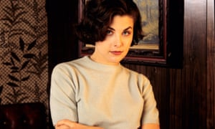
Audrey Horne (Sherily Fenn) likes sweaters, kilts and an LBD. Photograph: ABC Photo Archives/Walt Disney Television via Getty Images

Audrey Horne
The 18-year-old daughter of businessman Benjamin Horne, Audrey (Sherilyn Fenn) dresses to please herself. First seen in a demure sweater and pleated kilt, she changes from brogues to scarlet stilettos when she leaves her father’s car and arrives at school, a scene Spooner describes as an “intensely personal moment of autoeroticism”. This exploration continues, spelled out in clothes, as she and Agent Cooper get closer. We see Audrey in more sweaters, more kilts, in lingerie and – in the infamous cherry stalk scene – in an off-the-shoulder Little Black Dress. Her seductive dance in a kilt in the Double R diner, which contrasts Audrey with the distinctly ordinary fleece-clad Donna, is now a cult reference. It was reprised, with Fenn in black lace, for Twin Peaks: The Return in 2017. Thirty years on, Audrey Horne is still feeling herself.

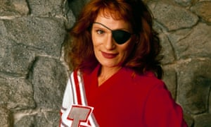

FacebookTwitterPinterest
Nadine Hurley (Wendy Robie) subverts the cheerleader look. Photograph: ABC Photo Archives/Walt Disney Television via Getty Images

Nadine Hurley
Spooner describes Nadine as an example of how the show up-ends our idea of a uniform as something that “should normally comfort us by showing everyone in their right place”. In Twin Peaks “they tend to disconcert us because there is something ‘off’ about them.” Indeed, a 35-year-old woman combining a cheerleader’s outfit with an eyepatch and wild hair is a through-the-looking-glass idea of an Americana icon, representing Nadine’s regression to her teenage self after a suicide attempt. If Nadine has spawned many Halloween costumes, her signature look has also gained relevance recently thanks to Cheer, the Netflix documentary about Navarro College’s cheerleading squad. It’s safe to say that when it comes to style, Nadine has made mat.

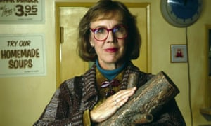

FacebookTwitterPinterest
The Log Lady (Catherine Coulson) pioneered retro geek chic. Photograph: ABC Photo Archives/Disney ABC Television Group

The Log Lady
If Lynch hadn’t made up the Log Lady, she might have appeared on Alessandro Michele’s Gucci catwalk anyway. Played by the director’s friend, Catherine Coulson, her outfit of a 70s-style cardigan, shirt, poloneck and oversized glasses has a retro geek chic feel that is now a familiar aesthetic. It was also the mood music around that statement log, reportedly valued at $275,000. Coulson’s character has since been celebrated as a patron saint of outsiders who are willing to live – and dress – as they please. The actor once described her character as “the most normal person on the show” and when Bravo showed repeats of Twin Peaks in 1993, the Log Lady introduced each episode. Lynch described her as the “hostess with the mostess [sic]”. The Log Lady’s legendary status was sealed with 2017’s The Return. While Coulson died in 2015, she stars in a moving posthumous performance, wearing those glasses with the breathing apparatus required to treat her cancer.

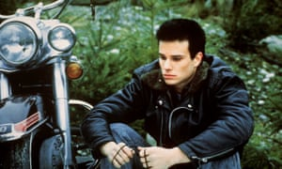

FacebookTwitterPinterest
James Hurley (James Marshall) dresses as a symbol of rebellion. Photograph: Alamy

James Hurley
In 2017, Vice called James Hurley both “the worst thing about Twin Peaks” and “the original sad lad”. Hurley is clearly meant to be a walking cliche, a cypher of American masculine teenage rebellion: you can tell because he wears a biker jacket and shades, and drives a motorcycle. Spooner points to Hurley’s biker jacket as an item that operates symbolically. Like his name, and his serenading of fellow teens, it’s an item that puts him in the same lineage as James Dean and Chris Isaak, while signposting gently that he’s not really worthy of all the women – Laura Palmer, Donna, Maddy – who fall for him. Reprising his much-trolled guitar playing for the new series, the jacket was noticeably absent – perhaps because a middle-aged man wearing one might spell something different, namely a mid-life crisis.

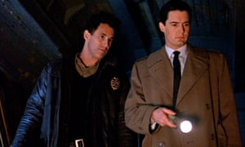

FacebookTwitterPinterest
Special Agent Cooper (Kyle MacLachlan, right) prefers a clean-cut look. Sheriff Harry S Truman (Michael Ontkean) is obliged to wear uniform. Photograph: CBS Photo Archive/Getty Images

Agent Cooper
Like Don Draper in Mad Men, Agent Dale Cooper is everything to Twin Peaks: hero, symbol, plot device, fashion reference. It’s his voice we hear first in the series, closely followed by a shot of him hanging upside down in tartan boxers and a clean white vest. Everything about Agent Cooper’s look is, as it is with Draper, clean, neat, presentable and uniform: short back and sides; crisp, fresh suit, trenchcoat. In a post-normcore world, this has been celebrated by fashion. Kyle MachLachlan, who plays Cooper, attended Balenciaga’s fashion show in 2018 with the label’s hyped designer Demna Gvasalia commenting that he was “always on my moodboard”. After The Return, in which MacLachlan plays five separate Coopers, Gvasalia’s moodboard will be full up. “His performance is masterful but obviously it is immeasurably assisted by costume,” says Spooner. “‘Bad Cooper’ is a particular stroke of genius – MacLachlan’s oddly neat ponytail and mod-inspired leather jacket are somehow exactly what you would expect Cooper possessed by the evil spirit of Bob to wear.”

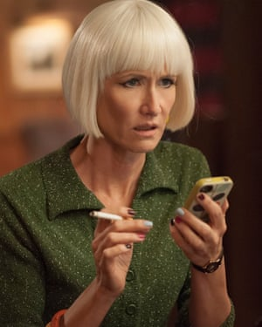
Diane (Laura Dern) likes a sharp bob and multi-coloured nails. Photograph: Suzanne Tenner/SHOWTIME

Diane
Everyone is a little bit in love with Laura Dern right now. David Lynch was way ahead of Renata Klein fans, though. The actor’s first major role was in his film Blue Velvet in 1986. While she didn’t appear in the original two series, she plays Diane in The Return. Yes, that Diane, the secretary to whom Agent Cooper sends recordings throughout the series, a woman he describes as “an interesting cross between a saint and a cabaret singer”. When we finally see Dern’s Diane – and, indeed, her doppelganger – they don’t disappoint. We see a razor-sharp bob, sometimes platinum, sometimes fire engine red; multicoloured fingernails and garments including a leopard jacket and emerald green pyjamas. “If the first two series were full of moments in which costume drew attention to itself, Diane’s costume always draws attention to itself,” says Spooner. “It also brings home how infrequently you see a middle-aged woman on screen dressed in a way that is quirky and eye-catching and unusual, yet positioned as stylish and cool, rather than ‘eccentric’ or ‘fashionista’.”

