Task 2. Do a written analysis of the given article and send it to your professor no later than the 22 of March. Also make a list of the vocabulary items you consider of importance to remember (5-6) + translation.

Glastonbury 2020: festival cancelled due to coronavirus outbreak
Festival confirms 2020 event due to feature Paul McCartney, Taylor Swift and Kendrick Lamar will no longer take place
Lanre Bakare and Steven Morris
Wed 18 Mar 2020 13.14 GMTFirst published on Wed 18 Mar 2020 10.58 GMT

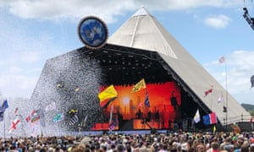
Years and Years perform on the Pyramid Stage at Glastonbury festival. Photograph: Michael Cragg/The Guardian
The Glastonbury festival, which was due to celebrate its 50th anniversary year in 2020 with headliners including Taylor Swift, Paul McCartney and Kendrick Lamar, has been cancelled as a result of the coronavirus pandemic.
The festival confirmed via Twitter on Wednesday that the event, which was set to take place from 24-28 June at its usual home of Worthy Farm in Somerset, was off “following the new government measures announced this week – and in times of such unprecedented uncertainty – this is now our only viable option”.
A statement from Michael and Emily Eavis said that although they hoped the situation in the UK would have improved by the end of June, it was not viable to spend the next three months with thousands of crew on the farm, and 2020 would therefore be “an enforced fallow year”.
“We were so looking forward to welcoming you all for our 50th anniversary with a lineup full of fantastic artists and performers that we were incredibly proud to have booked. Again, we’re so sorry that this decision has been made. It was not through choice,” they said.

We are so sorry to announce this, but we are going to have to cancel Glastonbury 2020. Tickets for this year will roll over to next year. Full statement below and on our website. Michael & Emily
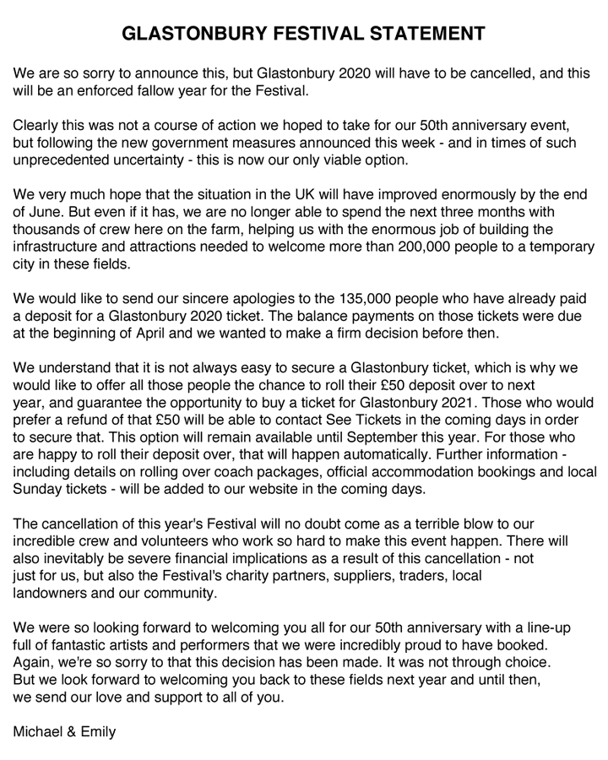
Ticket holders will have the chance to roll their £50 deposit over to next year, and guarantee the opportunity to buy a ticket for Glastonbury 2021, while those who want a refund can apply for one. Further information on coach packages, official accommodation bookings and other tickets will be added to the festival’s website in the next few days.


Sign up for the Sleeve Notes email: music news, bold reviews and unexpected extras

The festival had taken a business-as-usual approach until only a few days ago, announcing its third and final headliner – LA rapper Kendrick Lamar was unveiled as the Friday night bill-topper – last week.
Last Thursday, the festival announced an additional 90 acts – including Pet Shop Boys, Dua Lipa and Noel Gallagher – but less than a week later the impact of the Covid-19 virus was deemed so severe that the festival was no longer tenable.
The cancellation will be a huge blow to the festival, with some estimating losses could be as high as £100m, and will ruin its 50th anniversary year.
When announcing the lineup additions last week, Emily Eavis said they came “after much consideration given the current circumstances, and with the best of intentions”, but that they didn’t have a crystal ball and at that point were working hard to deliver the event while closely monitoring developments.
The announcements came shortly after the government’s chief scientific adviser, Sir Patrick Vallance, said that late June was likely to be just after the peak of the outbreak.
The festival has become one of the most celebrated cultural events in Europe since its humble beginnings as a gathering of 1,500 people in September 1970. It has grown into an event with more than 200,000 attendees, and its 50th anniversary year was set to be a vintage edition.
As well as Pyramid Stage headliners Lamar, McCartney and Swift other acts included Pet Shop Boys, Dua Lipa and Fatboy Slim, while Diana Ross was set to play the Sunday teatime “legend” slot, and Lana Del Rey, who would have played just before Lamar on the Pyramid stage.
Glastonbury is the latest high-profile cultural event or institution to be affected by the outbreak. English Heritage, which cares for more than 400 historic buildings, monuments and sites including Stonehenge in Wiltshire, is shutting its staffed areas from the end of Wednesday until 1 May.
The National Trust, which operates in England, Wales and Northern Ireland, is closing its pay-for-entry sites including houses, cafes and shops by Friday.
Senior managers at the National Trust for Scotland have also decided to shut its gated properties from Friday.
The National Trust said it would keep as many of its gardens and parklands open and not charge visitors in order to encourage people to enjoy fresh air during the period of social distancing.
On Monday evening, all major British theatres announced they were closing, while on Tuesday most big museums and galleries, including the Natural History Museum and the Tate facilities, said they would no longer be open to the public.

