- LAB 4. Graphic EMs & SDs.
- Issues for discussion:
- Graphic EMs & SDs.
- Punctuation marks.
- Print peculiarities. Graphon.
- Capitalization.
- Italics.
- Hyphenation.
- Multiplication.
- Graphic imagery
  - Reading matters:
- Lectures.
- Арнольд И.В. Стилистика современного английского языка. – М., 1981. – С. 138–160, 225–242.
- Shakhovsky V.I. English Stylistics. – М.: Издательство «КомКнига», 2008. – P. 98–99, 101.
Practical assignments:
- When I first saw you, I fell in love. Well, not LOVE love, but you smelled nice.
- An English professor wrote the words: “A woman without her man is nothing” on the chalkboard and asked his students to punctuate it correctly.
All the males in the class wrote: “A woman, without her man, is nothing”.
All the females in the class wrote: “A woman: without her, man is nothing”.
Punctuation is powerful.
- We can’t help everyone. But everyone can help someone.
- The b-b-b-b-bas-tud – he seen me c-c-c-c-coming (stumbling).
- You don’t mean to thay that thith ith your firth time (lisping).
- Alllll aboarrrrrd!
- I had a coach with a little seat in fwont with an iwon wail for the dwiver.
- Follow our advice: Drinka Pinta Milka Day.
- Best jeans for this Jeaneration.
- My daddy’s coming tomorrow on a nairplane.
- Two men have talked for some time in the train.
“Are you going to Brown’s lecture this evening?” says one of them.
“Yes”, answers the other.
“Don’t go. People say he is a very bad speaker”.
“I MUST go”, says the other. “I AM Brown”.
- We’ll teach the children to look at things. Don’t let the world pass you by, I shall tell them. For the sun, I shall say, open your eyes for that laaaarge sun…
- “ALL our troubles are over, old girl”, – he said fondly. “We can put a bit by now for a rainy day”.
- I say I hate you. H-A-T-E!
- 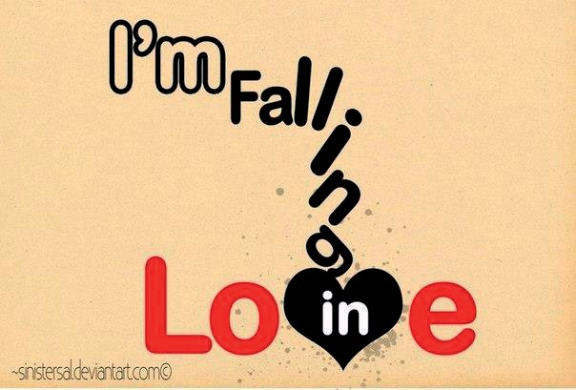
- 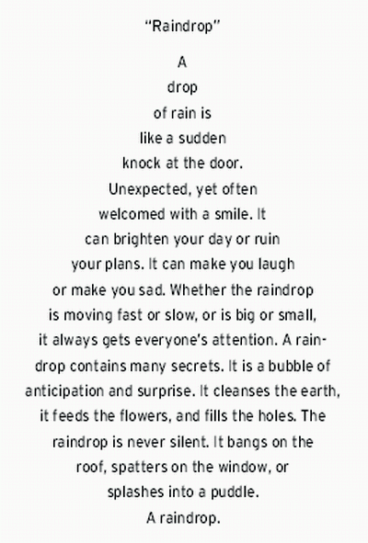

  - LAB 5. Stylistic differentiation of the English vocabulary. Issues for discussion:
- The concept of “literary language”.
- Stylistic classification of the vocabulary as a system.
- Three main layers of the vocabulary.
- Common colloquial.
- Neutral.
- Literary words.
- Special literary and special colloquial vocabulary.
- terms – professionalisms; professionalisms – jargonisms;
- neologisms – occasionalisms;
- vulgarisms – jargonisms – slang.
Reading matters:
- Арнольд И.В. Стилистика. Современный английский язык: Учебник для вузов. – 5-е изд., испр. и доп. – М.: Флинта: Наука, 2002. – С. 88–98, 113–130, 136, 138–147.
- Гальперин И.Я. Очерки по стилистике английского языка: Опыт систематизации выразительных средств. Изд. 2-е, испр. – М.: Книжный дом «ЛИБРОКОМ», 2012. – С. 89–112.
- Galperin I.R. Stylistics: Учебник. – 3-е изд. – М.: Высш. школа. – С. 57–69, 136–152, 154–166, 176–177, 246–248.
- Kucharenko V.A. A book of practice in stylistics: Учеб. пособие для студентов филол. фак. ун-тов, ин-тов и фак. ин. яз. – М.: Высш. шк., 1986. – С. 22–24, 37–66, 93–94.
- Shakhovsky V.I. English stylistics: Учебное пособие. – М.: Изд-во ЛКИ, 2008. – С. 35–46.
- Shakhovsky V.I. English Stylistics. – М.: Издательство «КомКнига», 2008. –
P. 99–101, 104, 130.
  - Practical assignments:
- Connotation is concerned with the associations which a word or expression has. For example, the word cowboy, as used in an expression like cowboy builders or cowboy plumbers, has associations of dishonesty and unreliability. An advertisement for an Indian firm of builders took the slogan: You’ve tried the cowboys. Now try the Indians. This slogan draws on two sets of connotations – the cowboy association mentioned above and the association of cowboys and Indians as from Wild West films. It neatly suggests that Indians, as the traditional opponents of cowboys, embody as builders the opposite characteristics of honesty and reliability. Black cats, for example, have associations with good luck in Britain and bad luck in the USA. Good modern dictionaries will give you information about widely shared connotations.

  - Can you match the colours with their connotations in English?
  - blue – purity
  - green – evil
  - yellow – miserable
  - red – inexperienced
  - white – danger
  - black – a coward
- What are the evaluative connotations in the following examples:
  - famous vs. notorious?

Make the correct choice of the stylistically marked words:
  - He began / commenced to scratch his back.
  - This honorable gentleman should be kicked out / expelled.

Speak about the difference between the contextual and the dictionary meanings of words:
  - He seemed prosperous, extremely married and unromantic.
  - I need young critical things like you to punch me up.
  - Marriage is a relationship in which one is always right and the other is the husband!
  - Everyone has three lives; a public life, a private life, and a secret life.
  - One day… I’m gonna make the onions cry.
  - Ten years ago we had Steve Jobs, Bob Hope and Johnny Cash. Now we have no jobs, no hope and no cash.
  - Always listen to you heart. Though it’s located on your left side… It’s still always right.
  - Journalism is printing what someone else does not want printed. Everything else is public relations. George Orwell
  - When “i” is replaced by “we” even “illness” becomes “wellness”.
  - Speak English, dress Italian, drive German, kiss French, be yourself.
  - Need cash for alcohol research. Advertising… It’s all in the presentation.
  - It is hard to be a woman. You must think like man, act like a lady, look like a young girl. And work like a horse.

Match the following formal and informal equivalents:
Literary type of communication | Colloquial type of communication
escape | get going
survive | get well
rise | get away
elude | get up
recover | get by

- Complete the table using the following words: shades, meal, kids, cop, ensure, umbrella, children. Do not fill the “- boxes”.
Neutral | Formal | Informal
 | offspring
sunglasses | -
policeman /  policewoman | police officer
 | - | brolly
 | repast | -
make sure |  | -
 | garments | clobber / kit
- Make these sentences formal or informal, as instructed.
  - Molly was there with her other half. He’s a nice chap. (formal)
  - Did you see that documentary about wales on TV last night? (informal)

What do you think are the present-day equivalents of these now outdated English words: apothecary, damsel, poesy, whither?
- Is the difference between the common literary and common colloquial vocabulary
clearly seen in the example from “Fanny’s First Play”?
  - “DORA: Oh, I’ve let it out. Have I? (contemplating Juggins approvingly as he places a chair for her between the table and the sideboard). But he’s the right sort: I can see that (buttonholing him). You won’t let it out downstairs, old man, will you?
JUGGINS: The family can rely on my absolute discretion.

Where in the following example is a term used as a SD? What function does the whole expression assume?
  - “What a fool Rawdon Crawley has been”, Clump replied, “to go and marry a governess. There was something about the girl too”.
“Green eyes, fair skin, pretty figure, famous frontal development”, Squill
remarked.

Do you agree that in an ordinary environment poetical words may also have a satirical function?
  - But Adeline was not indifferent: for
(Now for a common-place!) beneath the snow, As a volcano holds the lava more
Within – et cetera. Shall I go on? – No, I hate to hunt down a tired metaphor, So let the often-used volcano go.
Poor thing: How frequently, by me and others,
It hath been stirred up till its smoke quite smothers!
- How are such words as methink, haply, nay, travail, repast called?
- How are such words as aforesaid, hereby, therewith, hereinafternamed called?
- 14.Can you prove that in the example below the underlined words in italics are foreignisms not barbarisms?

  - “The little boy, too, we observed, had a famous appetite, and consumed schinken, and braten, and kartoffeln, and cranberry jam… with a gallantry that did honour to his nation”
- What layer do these blends belong to: musicomedy (music + comedy), cinemactress (cinema + actress), avigation (aviation + navigation)?
- What layer do these slang words belong to: rot, the cat’s pyjamas, grab, groove? What are their neutral equivalents?
- Do you know what these jargonisms mean: grease, gemman, brass?
- Put the following words into the correct column: tin-fish, a tiger hunter, to take stock in, loaf, bread-basket, piper.
Slang | Jargonisms | Professionalisms

What is the function of the southern dialect (in particular that of Somersetshire) in the following excerpt from Galsworthy’s “A bit of love”?
  - “Mrs. Burlacomble: Zurely! I give ‘im a nummit afore ‘e gets up; an’ ‘e ‘as ‘is brekjus reg’lar at nine. Must feed un up. He’m on ‘is feet all day, goin’ to zee folk that widen want to zee an angel, they’m that busy; an’ when ‘e comes in ‘e ‘ll play ‘is flute there. He’m wastin’ away for want of ‘is wife. That’s what ‘tis. On’ ‘im so zweet-spoken, tu, ‘ tis a pleasure to year ‘im – Never zays a word!”
- What makes these words vulgar: damn, bloody, to hell, goddamn?
- 21.What stylistic effect is produced if:

bookish or elevated words are used in a stylistically neutral context;
  - colloquial words are placed in a neutral context;
  - colloquial words are used in a literary context or vice versa?
  - “I should like,” said young Jolyon, “to lecture on it: Properties and quality of a Forsyte. This little animal, disturbed by the ridicule of his own sort, is unaffected in his motions by the laughter of strange creatures (you or I). Hereditarily disposed of myopia, he recognizes only the persons and habitats of his own species, amongst which he passes an existence of competitative tranquillity?”
  - “How thou art sentimental, maman!”
  - And the Gretans were very willing to feed and hide the Inglisi.
  - “He look at Miss Forsyte so funny sometimes. I tell him all my story; he is so sympatisch”.
  - She had said “Au revoir!” Not good-bye!
  - “We diarise, we earlierise, any day we may begin to futurise… We also itinerise, and reliablise; and we not only decontaminate and dehumidife but we debureaucratise and we deinsectise. We are, in addition, discovering how good and pleasant it is to fellowship with one another…
… let’s finalise all this nonsense”.
  - “To edge his way along the crowded paths of life, warning all human sympathy
to keep its distance, was what the knowing ones call “nuts” to Scrooge”

  - Father Knickerbocker met them at the ferry giving one the righthander on the nose and the other uppercut with his left, just to let them know that the fight was on.

Compare the neutral and the colloquial (or literary) modes of expression:
  - “I am Alpha and Omega – the first and the last”, the solemn voice would announce.
  - “I say, old boy, where do you hang out?” Mr. Pickwick responded that he was
at present suspended at the George and Vulture.

State the type and function of literary words in the following examples:
  - If manners maketh man, then manner and grooming maketh poodle.
  - “I am not in favour of this modern mania for turning bad people into good people at a moment’s notice. As a man sows so let him reap.”

Think of the type of additional information about the speaker or communicative situation conveyed by the following general and special colloquial words:
  - “What’s the dif”, he wanted to know.
  - “Here we are now”, she cried, returning with the tray. “And don’t look so miz”.
  - “Never heard anything so bloody daft in all my life”.
  - “No real sportsman cares for money”, he would say, borrowing a “pony” if it was no use trying for a “monkey”. There was something delicious about Montague Dartie. He.

Rewrite these sentences, replacing the underlined word with an explanatory phrase.
  - Example: Most of the time planes fly on autopilot. Most of the time planes fly automatically, controlled by a computer rather than the pilot.
  - The firm makes job applicants do a graphology test.
  - Johnny loves his cyberpet.
  - Matt’s a techo-wizard!
  - He’s giving a paper at a pre-conference event in Spain.
  - Is it OK if I post-date this cheque?

What words have been combined to make these blends? What do you think they mean?
  - infomercial
  - edutainment
  - cybrary
  - vegeburger
  - swimathon
  - fantastic
  - supercalifragilisticexpialidocious [suːpərˌkælɪˌfrædʒəlˌɪstɪkˌɛkspiːˌælɪˈdoʊʃəs]
  - beautificationalistically
  - hemidemisemiquaver
  - Mac Nazi
  - Abso-bloody-lutely!

Think of words that have come from your own language into English. Try to find words from these topic areas, which are particularly rich in loan words in English?
  - food and drink
  - flora, fauna and landscape features
  - industrial products and inventions
  - clothing and the home
  - politics ans society
  - the arts, sports and leisure activities

