TABLE OF FUNCTIONAL STYLES
Functional style substyle | Aim | Function | Language peculiarities | Examples
Belles-lettres style | To call feeling of pleasure and promote cognitive process | Aesthetico-cognitive | - use of words in contextual and very often in more than one dictionary meaning, or at least greatly influenced by the lexical environment.  - a vocabulary which will reflect to a greater or lesser degree of author's personal evaluation of things or phenomena;  - a peculiar individual selection of vocabulary and syntax, a kind of lexical and syntactical idiosyncrasy;  - the introduction of the typical features of colloquial language to a full degree (in plays) or a lesser one (in emotive prose) or a slight degree, if any (in poems)
- Poetry | To call feeling of pleasure and promote cognitive process | Aesthetico-cognitive | - orderly form, which is based mainly on the rhythmic and phonetic arrangement of the utterances  - imagery, that assumes in poetry a compressed form: it is rich in associative power | I never saw a man who looked  With such a wistful eye  Upon that little tent of blue  Which prisoners call the sky,  And at every drifting cloud that went  With sails of silver by.
- Emotive prose | To call feeling of pleasure and promote cognitive process | Aesthetico-cognitive | - allows the use of elements from other styles as well  - 2 forms of communication present – monologue and dialogue  - language of the writer follows the literary norms of the given period | «...their only way would be forhwith to make an end of themselves, either with knife, halter, or poison: for why, said he, should you choose life, seeing it is attendant with so much bitternes? But they desired him to let them go...»
- Drama | To call feeling of pleasure and promote cognitive process | Aesthetico-cognitive | - is entirely a dialogue  - he author’s speech is practically excluded except for the playwright’s remarks and stage directions  - the playwright seeks to reproduce actual conversation as far as the norms of the written language will allow | ABIGAIL: I want to open myself! . . . I want the light of God, I want the sweet love of Jesus! I danced for the Devil; I saw him, I wrote in his book; I go back to Jesus; I kiss His hand. I saw Sarah Good with the Devil! I saw Goody Osburn with the Devil! I saw Bridget Bishop with the Devil!
2. Newspaper style | To comment on, to inform of certain political, cultural, economic events to influence public opinion | To inform the reader | - alleges and claims, restrictions of time and space  - special political and economic terms, non-term political vocabulary, newspaper clichés, abbreviations, neologisms;  - syntactic constructions, indicating a lack of assurance of the reporter as to the correctness of the facts reported or his desire to avoid responsibility;  - complex sentences with a developed system of clauses;  - syntactical complexes: verbal constructions (infinitive, participial, gerundial) and verbal noun constructions;  - specific word order – five-w-and-h-pattern rule: (who-what-why-how-where-when);  - attributive noun groups (e.g. leap into space age);  - headlines are the most concise;
a) brief news items |  | To inform the reader | special political and economic terms;  non-term political vocabulary ; newspaper clichés \stereotyped expressions; commonplace phrases familiar to the reader\;abbreviations ;neologisms. complex sentences with a developed system of clauses; verbal constructions; syntactical complexes, specific word-order | "Technicians at the space base here are now working flat out to prepare GeAiini 6 for next Monday's blast-off." (Daily Mail)
b)advertisements and announcements |  | To inform the reader | In classified advertisements and announcements various kinds of information are arranged according to subject-matter into sections, each bearing an appropriate name.  The vocabulary of classified advertisements and announcements is on the whole neutral. | 
c) headlines |  | To inform the reader | often contain elements of appraisal, i.e. they show the reporter’s of the paper’s attitude to the facts reported or commented on. English headlines are short and catching. | New burger targeted for McLean times
d) the editorial |  | To inform the reader | extensive use of emotionally coloured vocabulary; combination of different strata of vocabulary, which enhances the emotional effect. | Two raids this week threaten the ability of news organizations to reveal official wrongdoing.  By The Editorial Board  The editorial board represents the opinions of the board, its editor and the publisher. It is separate from the newsroom and the Op-Ed section.  June 6, 2019
3. Publicistic style | To produce a constant deep influence on public opinion and to confine the receiver that the information is the correct one | To persuade | - combination of logical argumentation and emotional appeal;  - features, common with the style of scientific prose and emotive prose;  - coherent and logical syntactical structure, expanded system of connectives and careful paragraphing;  - use of words with <emotive meaning>, the use of other SD as in emotive prose, but the SD are not fresh or genuine;  - individual element is little in evidence here, generally toned down and limited;  - brevity of expression (sometimes epigrammatic) – leading feature;
a) oratory |  | To persuade | direct address to the audience (ladies & gentlemen, honourable members), contractions (I’ll, won’t, we’ve), the use of colloquial words. | It is rather for us the living, we here be dedicated to the great task remaining before us--that from these honored dead we take increased devotion to that cause for which they here gave the last full measure of devotion--that we here highly resolve that these dead shall not have died in vain, that this nation shall have a new birth of freedom, and that government of the people, by the people, for the people shall not perish from the earth.
b) essays |  | To persuade | Brevity of expression, reaching in good writers a degree of epigrammaticalness;  The use of the first person singular, which justifies a personal approach to the problems treated;  Use of connectives, which stress the process of correlation of ideas;  The abundant use of emotive words;  The use of similes and sustained metaphors. | "This family was a victim of a problem they could have avoided-a problem that, according to Florida park rangers, hundreds of visitors suffer each year. "Several times a month," Ranger Rod Torres of O'Leno State Park said, "people get scared and leave the park in the middle of the night." Those people picked the wrong kind of park to visit. Not that there was anything wrong with the park: The hikers camped next to them loved the wild isolation of it. But it just wasn't the kind of place the couple from New Jersey had in mind when they decided to camp out on this trip through Florida."
c)articles |  | To persuade | Words of emotive meaning, for example, are few, if any, in popular scientific articles. In a satiric article, on the contrary, their exposition is more consistent and the system of connectives more expanded. Literary reviews stand closer to essays both by their content and by their linguistic form. | A Forsyte is not an uncommon animal. (Galsworthy)
4. Scientific prose style | To prove a hypothesis, to create new concept, to disclose the eternal laws of existence/development and relations between different phenomena | To give logical progress of some ideas | - logical sequence of utterances with clear indication of their interrelations and interdependence; logical coherence of ideas expressed;  - objective, precise, unemotional, devoid of any individuality, striving for the most generalised form of expression;  - developed and varied system of connectives;  - use of terms specific to each given branch of science;  - sentence-patterns (postulatory, argumentative, formulative);  - based on facts already known, on facts systematised and defined;  - quotations and references;  - foot-notes, digressive in character;  - impersonality: frequent use of passive constructions;  - impersonal passive constructions are frequently used with the verbs suppose, assume, point out;
a) exact sciences |  | To give logical progress of some ideas |  | Choosing App Permissions App permissions are the privileges an app has—like being able to access your phone's camera or your laptop's contact list—but deciding which ones to switch on or off isn't an exact science.  — David Nield, WIRED, "How to See Everything Your Apps Are Allowed to Do," 5 July 2018
b) humanitarian sciences |  | To give logical progress of some ideas |  | Recent media coverage of studies about “gaydar,” the supposed ability to detect another’s sexual orientation through visual cues, reveal problems in which the ideals of scientific precision strip the context from intrinsically social phenomena.
c) popular- science prose |  | To give logical progress of some ideas |  | “Memorizing to-do lists and mathematical formulae came much later in our intellectual, social, and and neurological development.”
5. Official documents style | To reach agreement between two contracting parties | regulative and instructive | - conventionality of expression;  absence of any emotiveness;  the encoded character of language symbols;  a general syntactical mode of combining several pronouncements into the sentence.
a)diplomatic documents | To reach agreement between two contracting parties | regulative and instructive | many words have Latin and French origin | 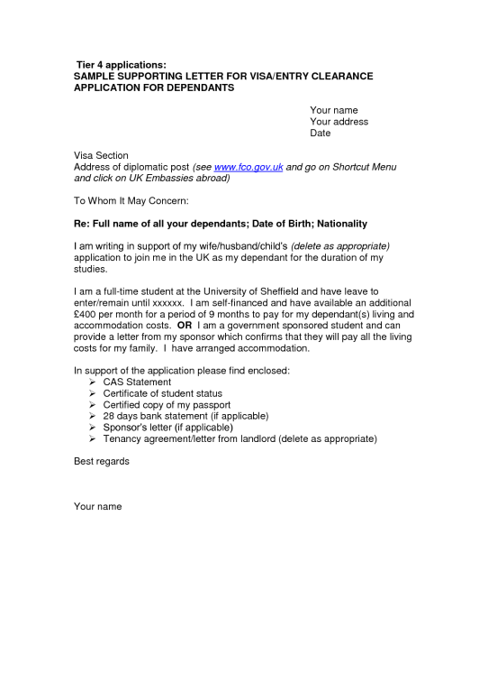
b) business letters | To reach agreement between two contracting parties | regulative and instructive | a definite compositional pattern, namely, heading, addressing, salutation, the opening, the body, the closing, complimentary clause, the signature.  The predominance of extended simple and complex sentences, wide use of participial constructions, homogeneous members | 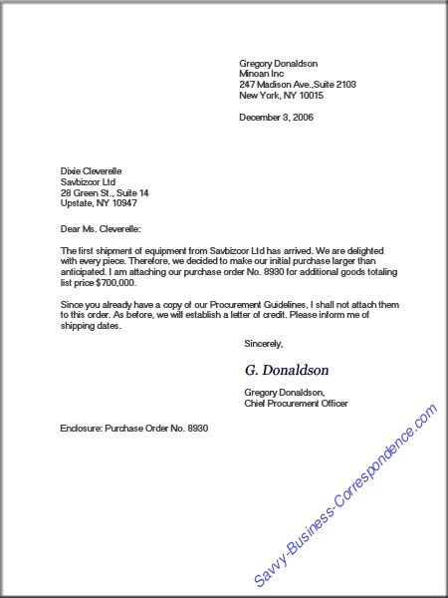
c) military documents | To reach agreement between two contracting parties | regulative and instructive | Abbreviations are used as signs of the military code, which is supposed to be known only to the initiated;  Metaphorical names are given to mountains, rivers, hills or villages, but these metaphors are perceived as code signs and have no aesthetic value | 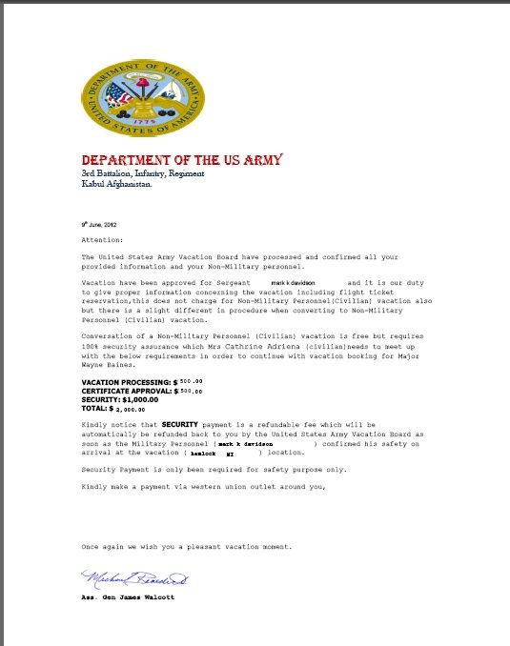
d) legal documents | To reach agreement between two contracting parties | regulative and instructive | vocabulary is conservative  contain a large proportion of formal and archaic words used in their dictionary meaning  many words have Latin and French origin | 

