Seminar # 13
FUNCTIONAL STYLES: BELLES-LETTRES AND NEWSPAPER

Questions for discussion
- Definition of functional style. The problem of functional styles’ classification:
R.A. Budagov, I.V. Arnold, M.N. Kozina, I.R. Galperin, Y.M. Skrebnev,
A.N. Morokhovsky, D. Crystal.
- Belles-lettres style: its definition, substyles, language peculiarities, function and aim.
- Language peculiarities of poetry, emotive prose and drama.
- Newspaper style: its definition, substyles, language peculiarities, function and aim.
- Language peculiarities of brief news items, advertisements and announce- ments, headlines, editorials.

Reading matter
- Lectures.
- Galperin I.R. Stylistics (Стилистика английского языка). – 3-е изд. – М.: Высш. школа, 1981. – P. 249–287, P. 295–307.
- Kukharenko V.A. A book of practice in stylistics (Практикум по стилистике английского языка). – М.: Высш. шк., 1986. – P. 108–111.
- Shakhovsky V.I. English Stylistics. – М.: Издательство «КомКнига», 2008. – P. 73–78, P. 81–86.
- Арнольд И.В. Стилистика. Современный английский язык: Учебник для вузов. – 5-е изд., испр. и доп. – М.: Флинта: Наука, 2002. – С. 320–322, C. 342–351.

Practical assignments

- Identify the functional style and substyle in each of the given texts and point out their distinctive features.

(1)
He did extraordinarily well in the war. He was a captain before he went to the front, and following the Argonne bat ties he got his majority and the command of the divisional machine-guns. After the Armistice he tried frantically to get home, but some complication or misunderstanding sent him to Oxford instead. He was worried now – there was a quality of nervous despair in Daisy’s letters. She didn’t see why he couldn’t come. She was feeling the pressure of the world outside, and she wanted to see him and feel his presence beside her and be reassured that she was doing the right thing after all.
For Daisy was young and her artificial world vas redolent of orchids and pleas- ant, cheerful snobbery and orchestras which set the rhythm of the year, summing up the sadness and suggestiveness of life in new tunes. All night the saxophones wailed the hopeless comment of the “Beale Street Blues” while a hundred pairs of golden and silver slippers shuffled the shining dust. At the grey tea hour there were always rooms that throbbed incessantly with this low, sweet fever, while fresh faces drifted here and there like rose petals blown by the sad horns around the floor.
Through this twilight universe Daisy began to move again with the season; suddenly she was again keeping half a dozen dates a day with half a dozen men, and drowsing asleep at dawn with the beads and chiffon of an evening dress tangled among dying orchids on the floor beside her bed. And all the time something within her was crying for a decision. She wanted her life shaped now, immediately – and the decision must be made by some force – of love, of money, of unquestionable practi- cality – that was close at hand.
That force took shape in the middle of spring with the arrival of Tom Bu- chanan. There was a wholesome bulkiness about his person and his position, and Daisy was flattered. Doubtless there was a certain struggle and a certain relief. The letter reached Gatsby while he was still at Oxford (F.S. Fitzgerald).

(2) (3)

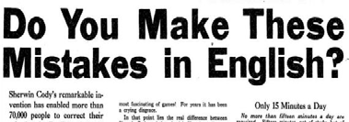

(4)
Death of a salesman
LINDA (hearing Willy outside the bedroom, calls with some trepidation): Willy! WILLY: It’s all right. I came back.

LINDA: Why? What happened? (Slight pause.) Did something happen, Willy? WILLY: No, nothing happened.
LINDA: You didn’t smash the car, did you?
WILLY (with casual irritation): I said nothing happened. Didn’t you hear me? LINDA: Don’t you feel well?
WILLY: I’m tired to the death. (The flute has faded away. He sits on the bed beside her, a little numb.) I couldn’t make it. I just couldn’t make it, Linda.
LINDA (very carefully, delicately): Where were you all day? You look terrible. WILLY: I got as far as a little above Yonkers. I stopped for a cup of coffee. Maybe it was the coffee.
LINDA: What?
WILLY (after a pause): I suddenly couldn’t drive any more. The car kept going off onto the shoulder, y’know?
LINDA (helpfully): Oh. Maybe it was the steering again. I don’t think Angelo knows the Studebaker.
WILLY: No, it’s me, it’s me. Suddenly I realize I’m goin’ sixty miles an hour and I don’t remember the last five minutes. I’m – I can’t seem to – keep my mind to it.
LINDA: Maybe it’s your glasses. You never went for your new glasses.
WILLY: No, I see everything. I came back ten miles an hour. It took me nearly four hours from Yonkers.
LINDA (resigned): Well, you’ll just have to take a rest, Willy, you can’t continue this way.
WILLY: I just got back from Florida.
LINDA: But you didn’t rest your mind. Your mind is overactive, and the mind is what counts, dear.
WILLY: I’ll start out in the morning. Maybe I’ll feel better in the morning. (She is taking off his shoes.) These goddam arch supports are killing me.
LINDA: Take an aspirin. Should I get you an aspirin? It’ll soothe you. […] (A. Miller)

(5) (6)
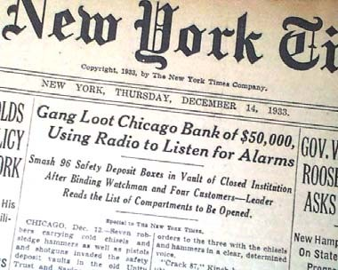

(7)
ROTTERDAM – Police said a town man had a half-pound of marijuana as well as cocaine, LSD, Xanax and oxycodone during a traffic stop on Thursday.

About 8:20 p.m., Logan J. Sinclair, 22, of Granville Avenue was arrested on multiple felony and misdemeanor counts of criminal possession of a controlled sub- stance and felony unlawful possession of marijuana.
Sinclair was arraigned in town court and sent to the Schenectady County jail on
$40,000 bail.

(8)
i shall imagine life
by E.E. Cummings

i shall imagine life
is not worth dying, if
(and when) roses complain their beauties are in vain

but though mankind persuades itself that every weed's
a rose, roses (you feel certain) will only smile

(9)
A New Phase in Anti-Obama Attacks
It is a peculiar, but unmistakable, phenomenon: As Barack Obama’s presidency heads into its twilight, the rage of the Republican establishment toward him is grow- ing louder, angrier and more destructive.
Republican lawmakers in Washington and around the country have been fo- cused on blocking Mr. Obama’s agenda and denigrating him personally since the day he took office in 2009. But even against that backdrop, and even by the dismal stan- dards of political discourse today, the tone of the current attacks is disturbing. So is their evident intent – to undermine not just Mr. Obama’s policies, but his very legiti- macy as president.
It is a line of attack that echoes Republicans’ earlier questioning of Mr. Obama’s American citizenship. Those attacks were blatantly racist in their message – reminding people that Mr. Obama was black, suggesting he was African, and planting the equally false idea that he was secretly Muslim. The current offensive is slightly more subtle, but it is impossible to dismiss the notion that race plays a role in it. …
… If this insurrection is driven by something other than a blend of ideological extremism and personal animosity, it is not clear what that might be. But it is ugly, it deepens mistrust of government and it harms the office of the president, not just Mr. Obama. (The New York Times, Editorial board, April 11, 2015)

Make your own illustration of poetry, emotive prose, drama, brief-news item, advertisement, headline and editorial in the form of a card. Mix all the examples in your card, make copies for a teacher and groupmates, prepare the answers only for yourself. Be ready to present your card in the class.

Seminar # 14
PUBLICISTIC AND SCIENTIFIC PROSE STYLE THE STYLE OF OFFICIAL DOCUMENTS

Questions for discussion
- Publicistic style: its definition, substyles, language peculiarities, function and aim.
- Language peculiarities of oratory, essay and journalistic article.
- Scientific prose style: its definition, substyles, language peculiarities, function and aim.
- Language peculiarities of humanities and exact sciences.
- The style of official documents: its definition, substyles, language peculiarities, function and aim.
- Language peculiarities of military, diplomatic, legal and business documents.

Reading matter
- Lectures.
- Galperin I.R. Stylistics (Стилистика английского языка). – 3-е изд. – М.: Высш. школа, 1981. – P. 287–295, P. 307–318.
- Kukharenko V.A. A book of practice in stylistics (Практикум по стилистике английского языка). – М.: Высш. шк., 1986. – P. 108–111.
- Shakhovsky V.I. English Stylistics. – М.: Издательство «КомКнига», 2008. – P. 78–81, P. 86–89.
- Арнольд И.В. Стилистика. Современный английский язык: Учебник для вузов. – 5-е изд., испр. и доп. – М.: Флинта: Наука, 2002. – С. 335–342.

Practical assignments

- Identify the functional style and substyle in each of the given texts and point out their distinctive features.

(1)
There is a considerable unanimity among all modern learning theories that learning is based on previously acquired knowledge and skills. However, learning is not a simple cumulative process in which all the new contents and skill components can be added to the prior ones. The prior knowledge has much more fundamental sig- nificance in human 3 knowledge construction process, because prior knowledge structures and conceptions act actively in many information processing and meaning making processes. For example the previous knowledge structures (mental models, mental presentations) tend to focus human perception and interpretation of perceived information, act on constructing new knowledge structures (or modifying the older ones) and making sense about the world around, as well as impact on procedures of storing on and retrieving from memory. In other words, when new information is

provided, learners try to interpret it in the context of their already existing representa- tions (e.g. Vosniadou, 1996; Jonassen et al., 1999).

(2)
Writing forms with boxes, though, is very cumbersome and forms are usually written using the letter x in place of the box. They are then called formulas. Then, in- stead of entering a number-phrase in the box, we will substitute the number-phrase for the letter x followed by the appropriate denominator.
[…]
A basic problem will consist of a data set together with a basic formula whose verb is one of the six basic verbs: =, ≠, <, >, ≤, ≥.

(3)
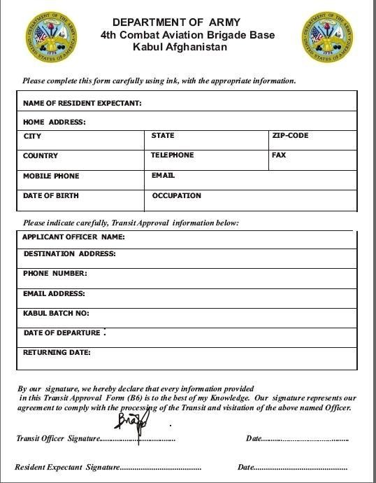

(4)
Cloning is creating a genetic copy or replica of cells, tissues, embryos, and genes of an already existing organism. Thanks to advances in new technology, clon- ing of animals has succeeded, but a human has not been cloned so far because of the lack of technology and the prohibition by governments. I think that a human cannot be cloned because human cloning involves many risks.
If human cloning became possible what would be the outcome of it? Basically I think human cloning is against the laws of nature. There is a well organized balance of nature and human cloning may damage this wonderful balance since the number of people would increase due to cloning and the natural resources would not be able to meet the needs of the increasing population. Therefore, there would arise shortages and people would not be able to find enough water and food to be able to survive. So human cloning would not be able to reach its original and most important aim, which is increasing human longevity.
Human cloning would also cause moral and ethical problems. Human cloning might change family dynamics in profound and unpredictable ways because a clone would have only a father or a mother. But a child needs both a mother and a father. There would be a lot of children who wouldn’t have both parents. So there would be new family dynamics. Also clones would always feel different and think themselves as objects not as humans. As a result, societies would be divided into two distinct groups as clones and humans. This would affect social life negatively because there would be discrimination in society. Humans would treat clones as objects and think them as their enemies because clones would have better qualities than humans. Therefore, this discrimination might even cause a big war in the world.
In my opinion, human cloning is very dangerous but cloning animals and or- gans is useful for the improvement of quality of human life and for the treatment of lethal diseases. Thanks to organ transplantation by cloning, people may be healthier and happier. Also cloning animals enables developments in science because more animals can be used for experiments. This is the useful side of cloning.
In sum, I think human cloning may cause a lot of big and important problems for people, clones and the world. However, I think cloning of animals and organs is beneficial to people and science. So “yes” to cloning of animals and organs, but “no” to human cloning.

(5)
Welcome and thank you all, dignitaries and guests, for coming today.
Dr K G Alexander, Chairman of Kerala’s Baby Memorial Hospital (BMH), warm congratulations to you and your team for transforming BMH from its humble beginnings as a 52-bed hospital in the 1980s. You can be proud of what you offer now – an 800-bed super and multi-speciality hospital, with over 40 medical and sur- gical departments and 16 operation theatres.
Your team of 300 doctors and over 2,000 nursing, paramedical are a part of In- dia’s reputation as a global healthcare destination and partner. They’re living your motto – “more than care!”

I’m delighted that BMH’s new state-of-the-art Burns ICU is being inaugurated today. It is your 15th ICU and a testament to your commitment to not just general healthcare but also to offering the widest possible range of intensive care.
[…]
Finally, I’m delighted to hear about some long-standing links that BMH’s team has with the UK. Many of you have trained and worked in the UK health sector for several years. These include your CEO, Dr Soman Jacob, your Chief of Orthopae- dics, Dr Mani, your Consultant Neonatologist, Dr Ranjith. And several of your doc- tors have Honorary Fellowships from UK Royal Colleges. I hope that you will de- velop those links even further with the UK and tell us where and how we can help.
Thank you once again.

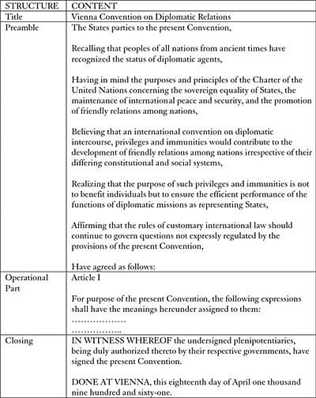
(6)

(7)
Last Will and Testament

I, the undersigned,

(full names)
……………………………………………………………………………………………………………………………… (Identity number)
……………………………………………………………………………………………………………………………… of (residential address)
………………………………………………………………………………………………………………………………
……………………………………………………………………………………………………………………………… hereby declare this to be my Will. I hereby revoke all previous wills or testamentary writings made by me.

I nominate (full name)
……………………………………………………………………………………………………………………………… (address)
………………………………………………………………………………………………………………………………
……………………………………………………………………………………………………………………………… to be the Executor of my Estate. Should he/she be unwilling or unable to act as executor,
I nominate (full name)
…………………………………………………………………………………………………………………..…………. (address)
………………………………………………………………………………………………………………………………
……………………………………………………………………………………………………………………………… I direct that the executor of my estate shall/shall not be required by the Master of the High Court or other competent authority to give security for proper performance of his duties. (give details of security to be given or draw a line through if not applicable).
……………………………………………………………………………………………………………………………..
…………………………………………………………………………………………………………………………….. I direct that my estate shall devolve as follows:
Special Bequests:
………………………………………………………………………………………………………………………………
………………………………………………………………………………………………………………………………
………………………………………………………………………………………………………………………………
………………………………………………………………………………………………………………………………
………………………………………………………………………………………………………………………………
………………………………………………………………………………………………………………………………
………………………………………………………………………………………………………………………………

After my special bequests I bequeath the residue of my Estate to:
………………………………………………………………………………………………………………………………
………………………………………………………………………………………………………………………………
………………………………………………………………………………………………………………………………
………………………………………………………………………………………………………………………………

In witness whereof I have signed this will in (place)
……………………………………………………………………………………………………………………………...
……………………………………………………………………………………………………………………………… on the ……… (day) of …………………….. (month)……………… (year) in the presence of the undersigned witnesses who in my presence and in the presence of each other have signed this will as witnesses.
Signed (TESTATOR) ………………………………………………..
WITNESS 1. ……………………………………………………….
WITNESS 2. …………………………………………………………

(8)
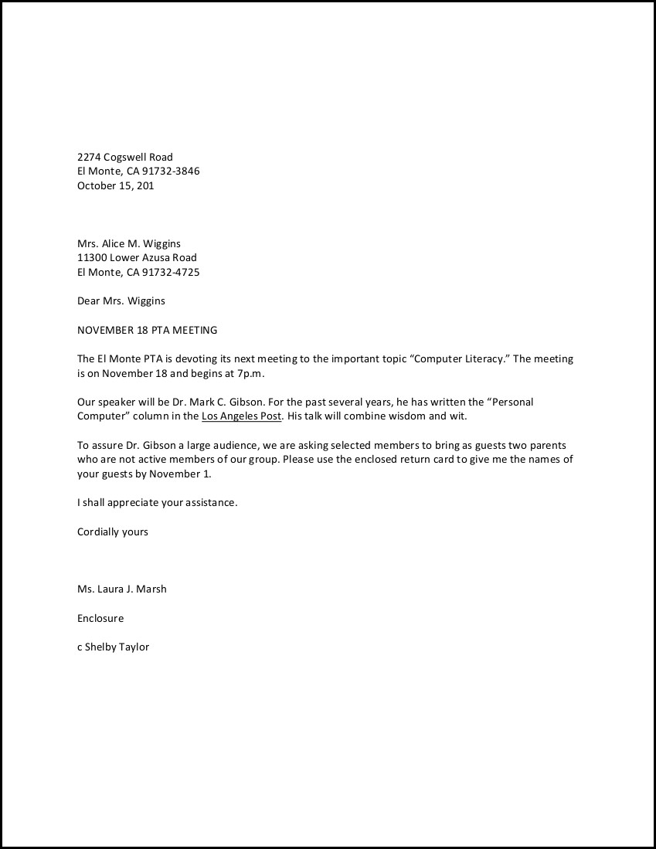

(9)
Redskins Change Their Name
Bowing finally to intense media pressure, the NFL Washington Redskins today announced that they are changing their name to the Washington Palefaces.
A change in the organization’s name had been under discussion for several years as a result of protests from liberal and Indian groups. Those groups appeared to believe that the name carried with it an implicitly racist perspective since it has been used to define people simply because of their skin color.
The Redskins organization had disputed that claim all along, saying the name had no racist implication whatsover, that, in fact, it represented “the more positive aspects of relations between Indians and whites,” affectionately recalling that time when Indians were considered “savages” because they fought a heroic but losing bat- tle against the white theft of their lands. They also pointed out that in poll after poll the vast majority (83%) of Americans now living on those former Indian territories do not see the term “Redskins” as offensive at all.
According to Tony Wyllie, spokeperson for the team, the new name was cho- sen because it carries with it the same positive values as the previous one. It recalls the same heroic era in American culture, the same sense of solidarity among Ameri- cans. And most importantly, it “just goes to show that names associated with skin color are completely benign and inoffensive.”
Copyright © Jim Sherry 2014

Make your own illustration of oratory, essay, article, the language of hu- manities and exact sciences, business, legal, military and diplomatic documents in the form of a card. Mix all the examples in your card, make copies for a teacher and groupmates, prepare the answers only for your- self. Be ready to present your card in the class.

