GitHub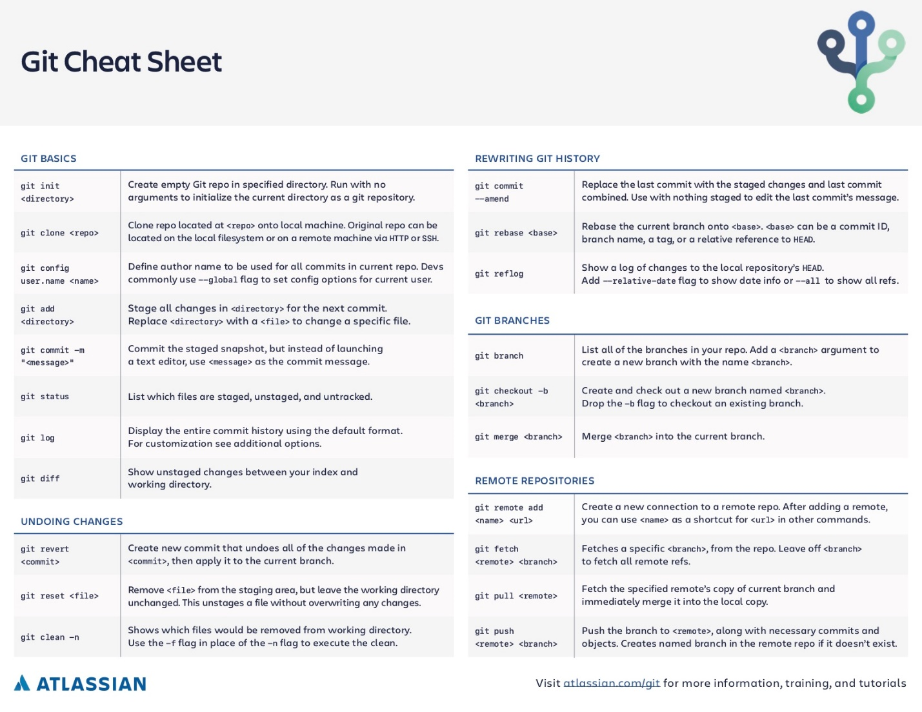
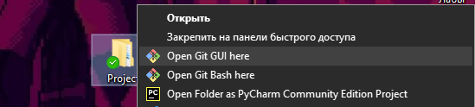
https://github.com/BorisovA49/Test5
git init
git add README.md
git commit -m "first commit"
git branch -M main
git remote add origin https://github.com/BorisovA49/ Test5.git
git push -u origin main/master

