Урок английского языка с ИД по теме "Мир профессий". 8-й класс

Цель: активизация лексики по теме, развитие коммуникативных навыков.
1. Организационный момент
Good morning, children. Glad to see you. How are you? What season is it? What can you say about weather in winter? Good for you, thank you. Boys and girls look at the screen and guess: what is the topic of our lesson? Yes, you are right. Our topic is: “The world of jobs”. Today we’ll repeat new words, do some exercises, sing songs, check up your hometask.
2. Look at the screen and repeat the words after me. Translate, please.
- Architect
- Dentist
- Lawyer
- Computer operator
- Air host
- Accountant
- Engineer
- Electrician
- Designer
- Translator
- Journalist
- Librarian
- Fashion model
- Police officer
- Fireman
- Hairdresser
- Travel agent
- Musician
3. Form compound words to name some jobs
- Police
- Officer
- Master
- Maker
- Customs
- Woman
- School
- Man
- Green
- Assistant
- Congress
- Grocer
- Mistress
- Shop
- Head
- law
- Cow
- Boy
- Dress
(ОТВЕТ)
- cowboy
- headmaster
- Schoolmaster
- Headmistress
- Schoolmistress
- Congressman
- congresswomen
4. Say what occupations are described here:
- a job of selling goods
- a job of cutting men’s hair
- a job of stopping fire
- a job of writing novels
- a job of helping to control a ship
- a job of reading the news on the radio
- a job of making bread
- a job of pulling out bad teeth
- a job of making medicines
- a shop assistant
- a barber
- a fireman
- a writer
- a sailor
- an announcer
- a baker
- a dentist
- a chemist
5. Say whom you would contact if:
- Your house were on fire
- Your car were broken down
- You wanted to go to a nice place for a holiday
- Your hair were getting long
- You had a problem with one of your teeth
- You wanted a portrait photograph of yourself
- You wanted to redecorate your flat
- Your piano were not sounding right
- a fireman
- an auto mechanic
- a travel agent
- a hairdresser
- a dentist
- a photographer
- an interior decorator
- a piano tuner
6. Say what you would do if you did these jobs. (If I were... I would...)
- a plumber (put in and mend water - papers)
- a barber (cut hair)
- a receptionist ( welcome visitors)
- a chemist ( make and sell medicines)
- an interior decorator (decorate flats and offices)
- a piano tuner (tune pianos)
- an estate agent (buy and sell flats )
- an optician (make glasses)
- a hairdresser (cut and arrange hair)
- a travel agent ( plan holidays)
7.Сhoose the right word to complete these sentences
1. An ...is a person who drives a railway engine.
a) engine officer
b) engineman
c) engine driver
2. Someone who makes walls with bricks is a...
a) wallmaker
b) bricklayer
c) brickmaker
3. A ...is a person who cuts men’s hair.
a) hairman
b) hairdresser
c) barber
4. Rubbish is collected by...
a) rubbish collectors
b)refuse collectors
c) dustmen
5. A...is a person who makes men’s clothes.
a) tailor
b) dressmaker
c) coatsmen
6. A person who prepares food is a...
a) cook
b) cooker
c) cook specialist
8. Now let’s work in pairs. Divide into 5 groups
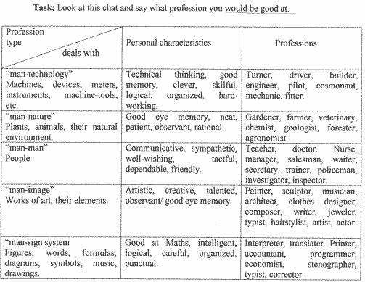
Would you check up your homework?
Whose project was very interesting?
Tell me please what have you known at the lesson?
Thank you for the lesson. Good bye.

